1. **Online Search**

EndNote’s search interface provides a simple way to do basic searches of online databases. To search and retrieve references from an online database, you should initiate the online search from the Tools menu, select ONLINE SEARCH to display the collection of connection files installed on your computer or click Plus button to select the desired database, from which you can retrieve references.

* 1. Click Plus button to add and select a database .



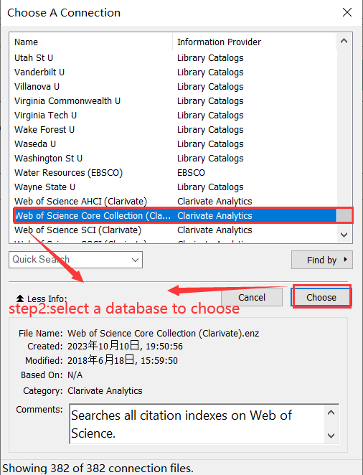

* 1. Select a database on your computer.



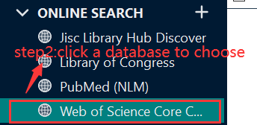

1. **Retrieve References**

Once you select a database, you will see several search fields appearing on the window. Enter your search request in the search fields on the Advanced Search panel, and then click Search. EndNote searches the database and displays the number of references that were found to match your search criteria.

1. Add/Delete search field.

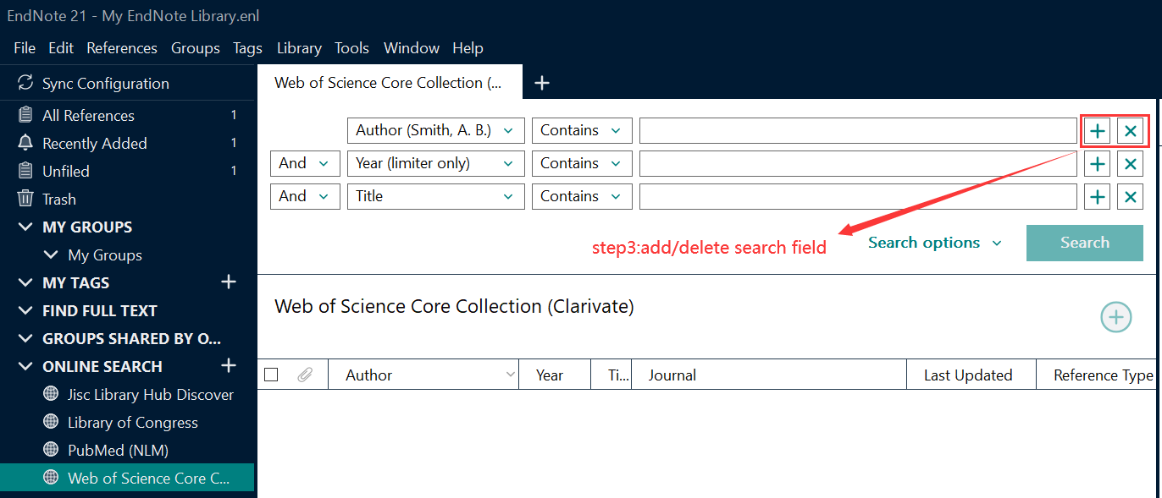

1. Set search field title.

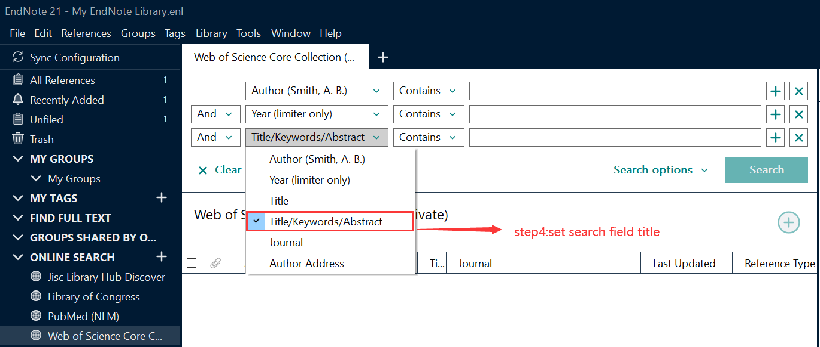

1. Enter keywords.

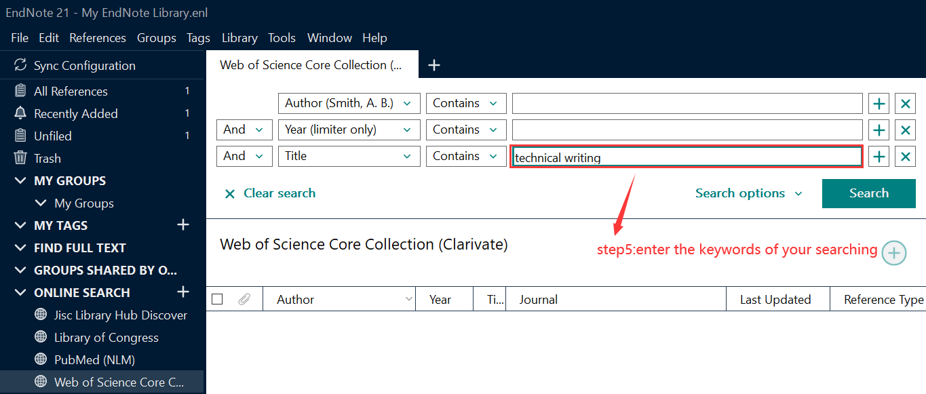

1. Click Search.

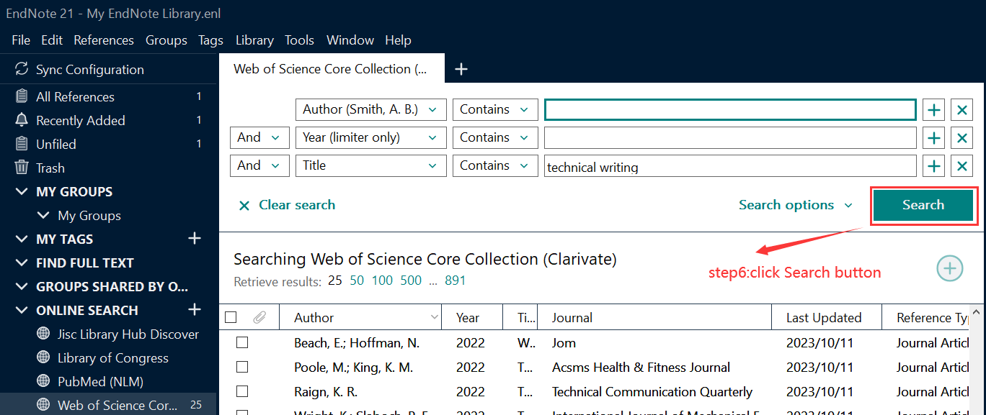

1. **Copy Retrieved References**

After you click Search button, the retrieved references are stored in the Online Search group set for the library, but they are not yet in your EndNote library. Now you have choices on how to add the references to your library.

* 1. Go to the References menu and select Copy References To in order to select a new or existing library and copy the selected references to that selected library.

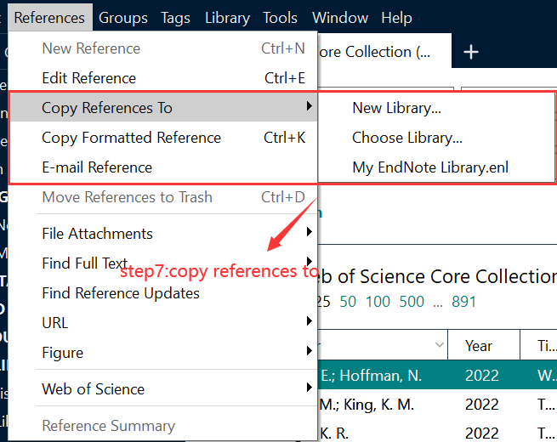

* 1. Right-click on the selected references and select Copy References To from the list in order to select a new or existing library and copy the selected references to that selected library.

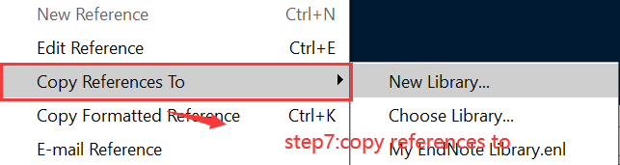

* 1. Drag and drop the references into the group you want to add them to in the library.
  2. Mark the references using the checkmark boxes to the left of them, and then click the Add the selected records to your local library button to add them to your library.

